PROJECT REPORT ON

GOVERNMENT ARTS AND SCIENCE COLLEGE

SUBMITTED BY,

GAYATHRI

IDHAYA

ELAKKIYA

GUNALI

UNLOCKING INSIGHTS INTO THE GLOBAL AIR TRANSPORTATION NETWORK WITH TABLEAU

INTRODUCTION:

* 1. PROJECT ARE VIEW:

Air transport is one of the fastest modes of public transport which connect the international boundries.

* 1. PURPOSE:

It generates economic engine to generate and support jobs strengthen trade and connectivity between people and countries promote tourism and connect remote communities.

2. PROBLEM STATEMEND:

In regions are not readily accessible to other modes of transport is considered to be the only means of transpord.

2.1 EMPATHY MAP:

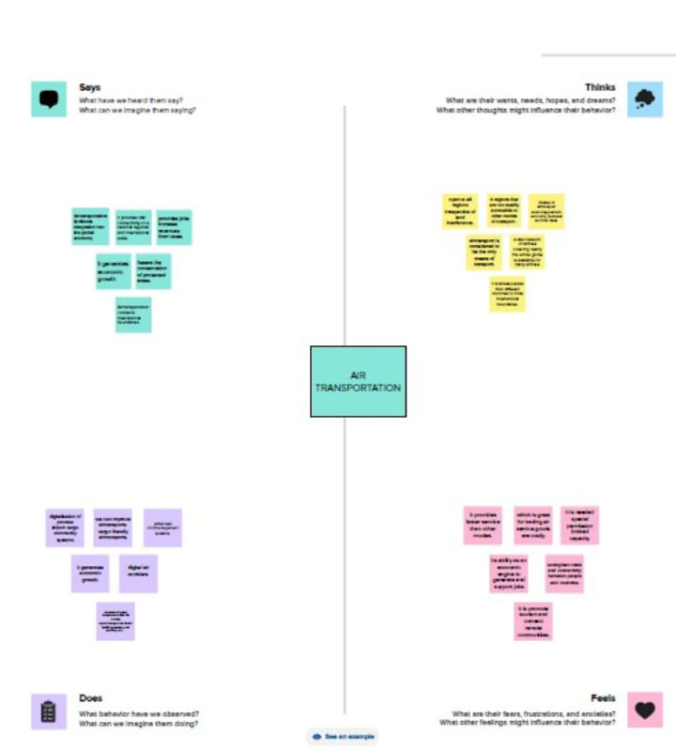

2.2 IDEATION AND BRAINSTORM MAP:

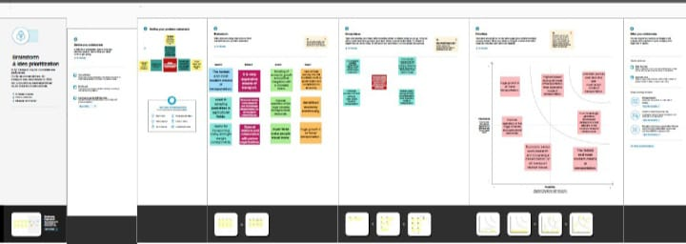

3.RESULT :



4.ADVANTAGE AND DISADVANTAGE:

It provides faster service than other models which is great for trading air and model special permission limited capacity.

5.APPLICATION:

Air transport intergration into the glopal economy and provides vital connetivitty on a national.

6.CONCLUSION:

In regions that are not readily accessible to other modes of transport .